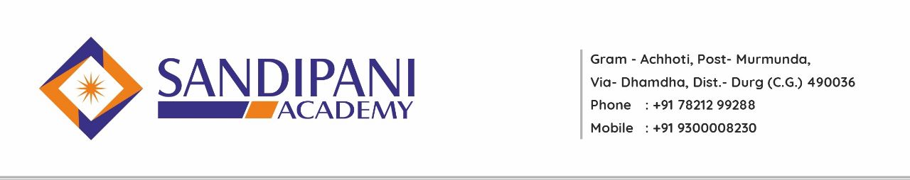
Academic Calandar
B. Ed II Semester
Session 2022-2023

Date: - 08/02/2023
Month | Activities Academic |  | Co-curricular Activities
March 2023 | Explanation of B.Ed.II Semester Curriculum  Commencement of classes  2 Unit of Each Subjects including  Elective Subject  Orientation Lecture on School Observation  School Observation Copy Distribution |  | Assembly ( NEWS Reading, Thought of the Day)  Guest Lectures  Life Skill Program  National Days Celebration  Co-Curricular Activities
April 2023 | Providing Assignment  One Month School Observation |  | Participation in School Activities
May  2023 | Assignment Submission  2 Unit of Each Subjects including  Elective Subject |  | Saturday/Cultural Activities  Sports Day Celebration  Guest Lecture  Microteaching  Co-curricular Activities
June  2023 | 1 Unit of Each Subject  Including Elective Subject  Remedial Class |  | Students Submission of Examination Form  School Observation Copy Submission
June  2023 |  | University Examination

Principal/ H.O.D

